1. This query looks for customer IDs that appear in both the Customers and Orders table. The resulting table should only return the customer’s first name, last name and order date. Then the table sorts the order by the customer’s last name. If there are any duplicate last names, it will sort using the customer’s first name. If there are further duplications, it will sort the tuples by the order date. Customer last name and first name are sorted in ascending order, while the order date is sorted in descending order.
2. SELECT CustFirstName, CustLastName, OrderDate

FROM Customers c JOIN Orders o

ON c.CustomerID = o.CustomerID

ORDER BY CustLastName, CustFirstName, OrderDate DESC;

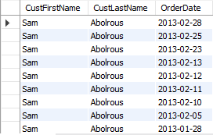

1. SELECT CustFirstName, CustLastName, OrderDate

FROM Customers c

LEFT JOIN Orders o

ON c.CustomerID = o.CustomerID

WHERE o.OrderNumber is NULL

ORDER BY CustLastName, CustFirstName, OrderDate DESC;



1. SELECT CustFirstName, CustLastName, OrderDate

FROM Customers c JOIN Orders o

ON o.CustomerID = c.CustomerID

WHERE o.OrderNumber =

    (

    SELECT MAX(OrderNumber)

    FROM Orders

    WHERE CustomerID = c.CustomerID

    )

ORDER BY CustLastName, CustFirstName, OrderDate DESC;

